Hey Kids
Kay and Bec have sent me on this special mission to guide you through the coming weeks as we do Church online, how exciting! I told them I would do a super sparkly job at looking after you. Are you ready for some Blastoff family fun and teaching? I can’t wait for us to get started,
Sparky

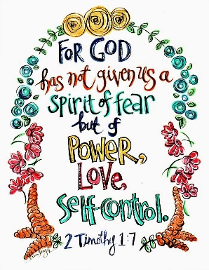

- Task 1 – Watch the Fruits of the Spirit Clip
(appropriate for your age)

- Task 2 – Let’s talk! (ask questions according to age)
The Fruits of the Spirit are LOVE, JOY, PEACE, PATIENCE, KINDNESS, GOODNESS, FAITHFULNESS, GENTLENESS AND SELF-CONTROL. Which one is your favourite?
How can we describe self- control?
Has there been a time when your thoughts and feelings have made you react?
What could we do differently, so we don’t lose our self-control?
- Task 3 – Interactive
Put some peaceful, calming music on and then take it in turns to:
Name 3 things you can see
Name 2 things you can hear
Name 1 thing you can smell

This is a mindfulness activity that can be used to help us take back control of our thoughts and feelings before we react.

- Task 4 – Activity (Suggested to do while we sit to watch Church Online)

This is your circle of control. If possible, you can print this off or alternatively you can grab a piece of paper, some pens and draw your own circle of control. Understanding what we can and cannot control will help us with our own self-control.
- Draw a circle and then draw a circle within the circle.
- On the outside write some of the things you can’t control.
- Write on the inner circle things you can control
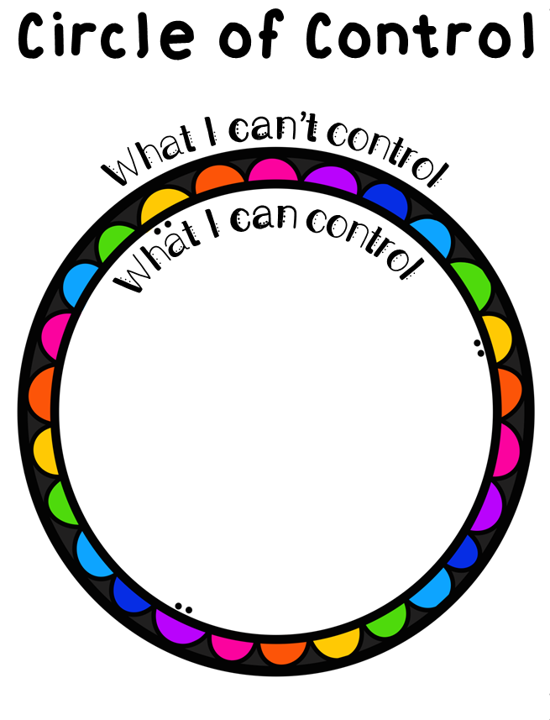

Thanks for joining us today, on behalf of myself and Arise Church we hope you’ve had a great morning. God Bless you and see you next week,
Sparky

